Class: 5th April 2018

In today’s class we have discussed the following topics

• What is R

• Download and install R

• RStudio

• R Basics operations

• R Vectors and R data types

• R- Help

• Some arithmetic

• Matrix

• Data plotting

• Accessing a Matrix

**Class Note**

**What is R:**

R is a free software environment for statistical computing and graphics, [http://www.r-project.org](http://www.r-project.org/). It compiles and runs on a wide variety of UNIX platforms, Windows, and Mac OS. Over the last ten years, R has become one of the most widely used statistical software packages among statisticians and researchers since it provides more than 4000 specialised packages.

*R is unique* because it gives the developer the power to do three things in one single tool:

1. **Data Manipulation:** R allows the data scientist to shape the dataset into a format that could be easily accessed and analysed by slicing large multivariate datasets. In my opinion, it is one of the very few tools that have great indexing techniques.
2. **Data Analysis**: Any kind of statistical data analysis could be found in R. R is an open source development tool that is supported by a large community of statisticians and computer scientists. It has over 4000 packages that implements various statistical analysis tools related to hypothesis testing, model fitting, clustering techniques, and machine learning.
3. **Data Visualisation**: R is "the package" for data visualisation. There are many on the shelf graph functions in R that are ready to be used. The best part of R is that it gives the developer capabilities to implement any visualisation idea for any dataset. In addition, animated and interactive graphs could be implemented easily in R.

**Download and install R**

We already did download R in our system. But for future reference, please first download and install R and then install RStudio. Otherwise some dependencies will be missed form the RStudio.

Download Links:

R: <https://cran.r-project.org/>

RStudio: <https://www.rstudio.com/products/rstudio/download/>

NB: use default configuration while installing both the software.

**RStudio GUI**

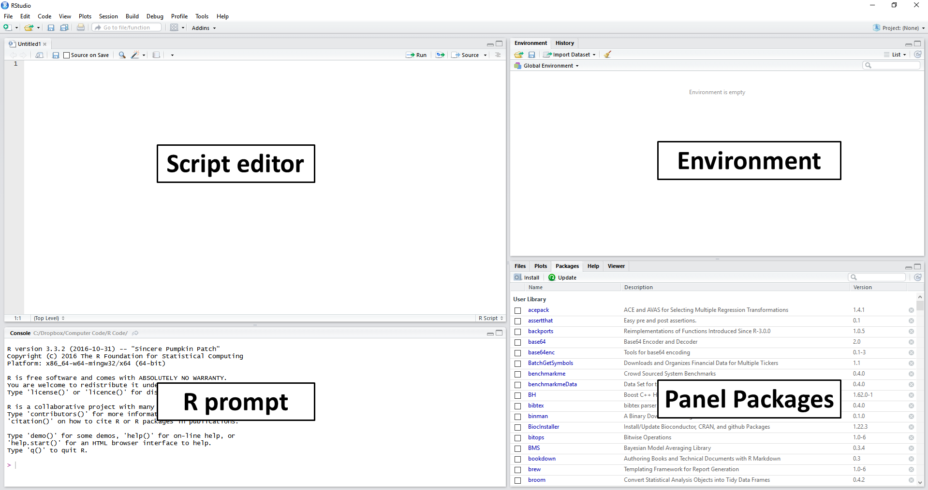

In the Script editor section, we will write our code and edit.

In the R prompt, we will write code in the Terminal/shell/Command Prompt (what we did today)

In the Environment section, you may find the history and database connection. There are other things in this section which will be discussed later.

In the Panel Package, you will see an Explorer of the files in your system. There are also some options that will be discussed later.

**Basic Operations in R**

**Assigning a value to an object**

Assignment to an object is denoted by "<-" or "->" or "=".

Example:

x -> 5

x = 5

5 <- x

**Vector in R**

c(data_will_be_kept_here_seperated_by_commas)

here, c() is a concatenation operator.

Example:

Age <- c(15, 17, 16, 15, 16)

Marks1 <- c(90, 86, 70, 88, 45)

Marks2 <- c(85, 80, 74, 39, 65)

Name <- c("John", "Bob", "Nick", "Smith", "Rick")

**Get Data From Vector**

VariableName[Index_Number]

NB: Index number in R starts from 1.

Example:

Age[4]

This will return: [1] 15

Here [1] is not important for now.

Name1[3]

This will return: [1] “Nick”

If you want to get all the data from a vector but one index missing, you can do like the following way.

Age[-4]

This will return all the elements in Age vector without the 4th element.

Output: [1] 15 17 16 16

**Assignment:**

Practice with other variables.

**Sequence in R**

Sequence in R is made using a function seq(). The structure of the function is as follow.

Seq(from = Starting_Number, to = Ending_number, by = Increment or decrement)

Example:

seq(from = 1, to = 5, by = 1) will return [1] 1 2 3 4 5

NB: if we need to increment numbers by 1, we can do like the following format.

1:5 will give an output from 1 to 5.

[1] 1 2 3 4 5

**Assignment:**

Practice with fractions and check with negative values in the function.

**Repletion in R**

In R, we can repeat things using rep() function. The structure of the repeat function is as follow.

rep(what_will_be_repeated, times= How_many_times)

Example:

rep(123, times = 3)

output: [1] 123 123 123

**Assignment:**

Practice with other data types and use vectors inside the rep() function.

**Arithmetic Operations**

**Assignment:**

Use all basic arithmetic in R for 2 or 3 variables.

**Matrix in R**

To declare a matrix, we need to use a vector inside the matrix() function. The structure of the repeat function is as follow.

matrix(a_vector_containing_all_the_elements_for_a_matrix, nrow = number_of_rows, byrow=TRUE_or_FALSE)

Example:

matrix(c(1,2,3,4,5,6,7,8,9), nrow = 3, byrow = TRUE)

output:

[,1] [,2] [,3]

[1,] 1 2 3

[2,] 4 5 6

[3,] 7 8 9

NB: To swap between row and columns change *byrow* from TRUE to FALSE or vice versa.

**Accessing a matrix**

You need to assign the matrix to a variable as follow first.

Mat <- matrix(c(1,2,3,4,5,6,7,8,9), nrow = 3, byrow = TRUE)

see the following operations and outputs:

Mat[1,2]

Output: [1] 2

Mat[c(1,2),3]

Output: [1] 3 6

Mat[2,]

Output: [1] 4 5 6

Mat[,3]

Output: [1] 3 6 9

**Basic Arithmetic in a Matrix**

**Assignment:**

1. Multiply and divide all element in an integer type matrix by 5 and print the result
2. Access [2,3] and [3,2] elements at the same command and print output. [hints: use vector]

**Data Plotting in R**

Using plot() function we can plot data in R. we will know details in the next class.

Example:

x <- 1:10

y <- 11:20

plot(x,y)

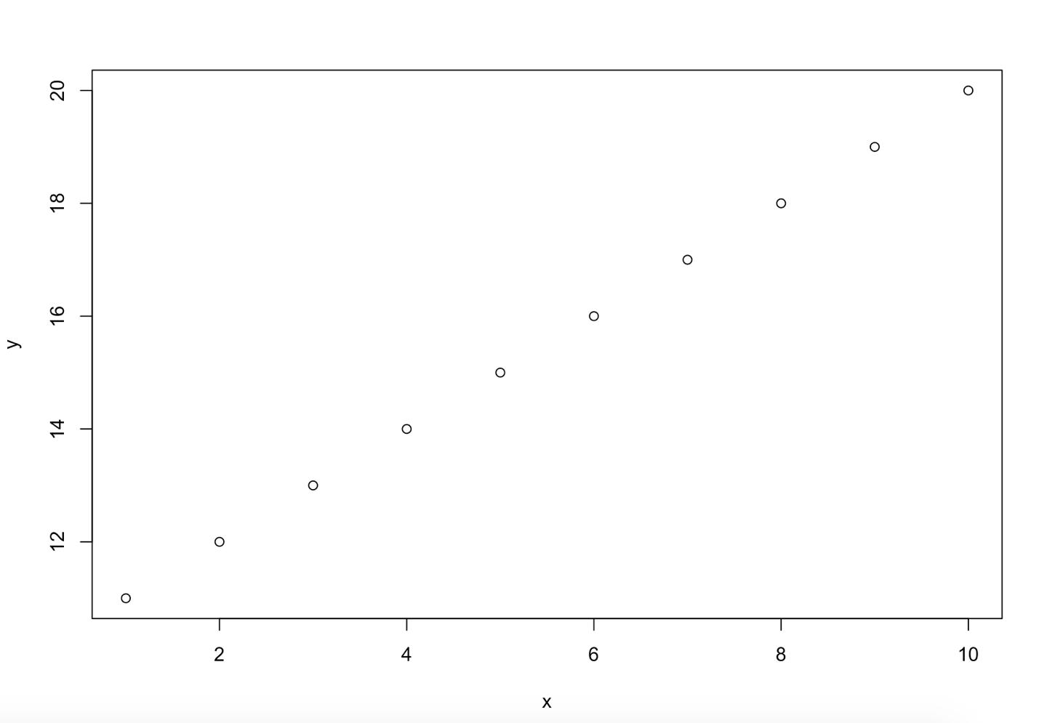

**Assignment:**

1. What will be the output of the following plot?

x <- seq(-pi,pi,0.1)

plot(x, sin(x))

1. Plot x vs y graph while x is 1 to 100 and y is 12 to 1002

**Accessing Help menu**

?name_of_the_topic

Example:

?mean will show you helps with mean in math.

help.search(‘weighted mean’)

This will search weighted mean in the documentation

help(topic_name)

**END OF THE CLASS**

**Next class topics:**

1. Sorting a vector
2. Reversing a vector
3. Getting the elements number
4. Getting unique elements in a vector
5. Using some math functions:
   1. Log
   2. Exponential
   3. Sum
   4. Mean
   5. Max
   6. Min
   7. Rank
   8. Round
   9. Correlation
   10. Variance
6. Matrix Multiplication
7. Lists
8. Plotting operations
   1. Add titles to Axes
   2. Changing color of the graph
   3. Overlaying graphs